**Homework #2: Modelling of dynamical systems**

**Problem 1.** Obtain the transfer functions  and the following mechanical system

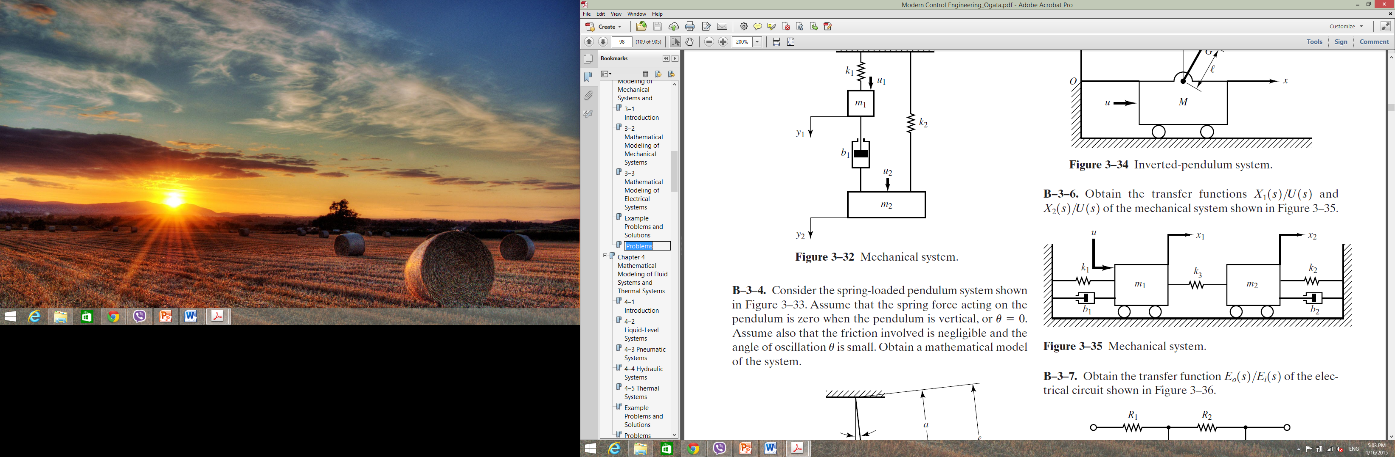

**Problem 2.** Obtain the state space model of the mechanical system given in Problem 1 with 

**Problem 3.** Obtain the transfer function of the system.

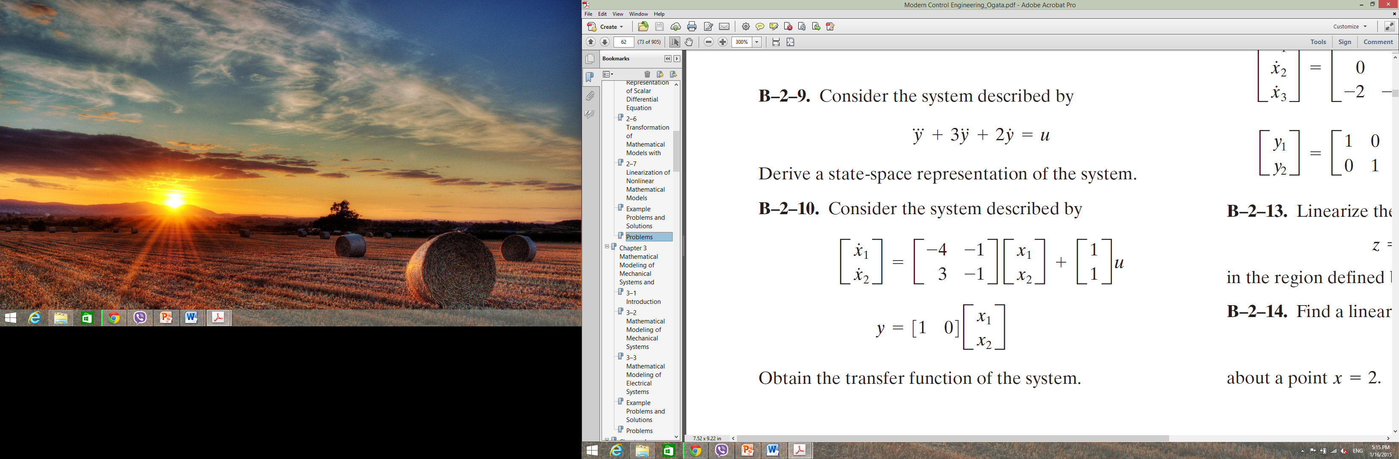

Check the result using Matlab.

**Problem 4**. Consider the dc servomotor system.

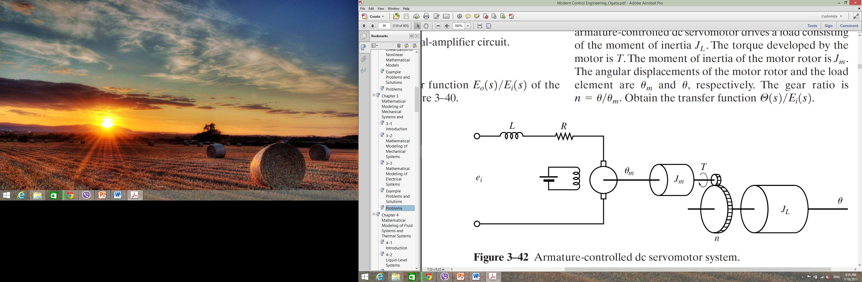

: motor displacement

: load displacement

: moment of inertia of the load

: moment of inertia of the motor

*n* : gear ratio

Obtain the transfer function 